# Workshop 5 - CSY2085 – Server Administration and Security

## Workshop 5 – Windows Server Storage

STUDENT NAME: Muhammad Raza

STUDENT NUMBER: 21624838

## Task 1 - Creating and configuring a Simple Dynamic Disk

1. Now capture and paste your own screen below:  
   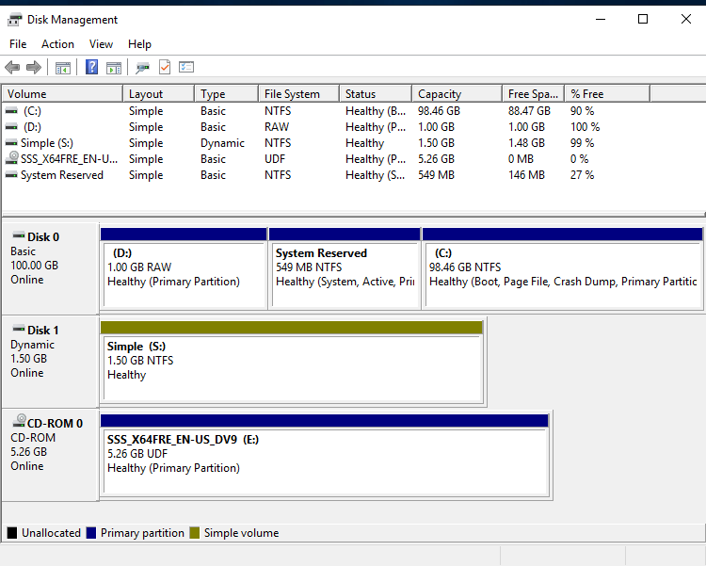

## Task 2 - Extending the Simple Disk to a Spanned Set

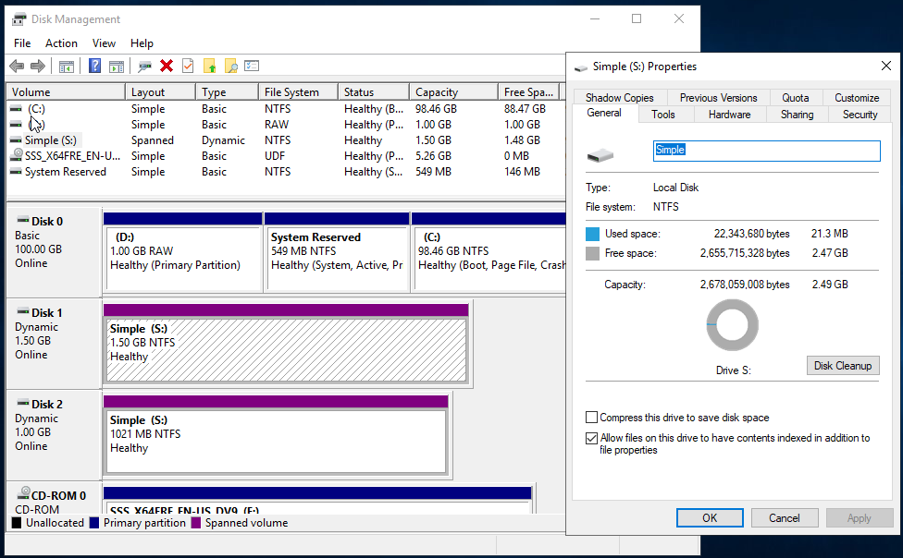

**Question 1 – What happened to your original text file? Did it remain the same, or was it altered or deleted?**   
The original text file remained the same after extending Drive S: into a Spanned Drive. Spanning volumes simply extends the space without affecting existing data. Thus, your text file in Drive S: was neither altered nor deleted during this process. Ensure to check the file's contents to confirm its integrity.  
  
**Question 2 – What has happened to Drive S: and your text file?**

Drive S: became inaccessible after removing “Disk-2-your-student-id” as it was part of the spanned volume. Consequently, the text file is also inaccessible because spanned volumes require all disks to be present to function.

**Question 3 – Does a Spanned Drive have any protection against disk failures?**   
No, a Spanned Drive does not have protection against disk failures. If any disk in the spanned volume fails, data on the entire volume becomes inaccessible. Spanned volumes prioritize capacity over redundancy.

## Task 3 - Creating a Mirrored Disk

1. Paste your own screen shot below:  
   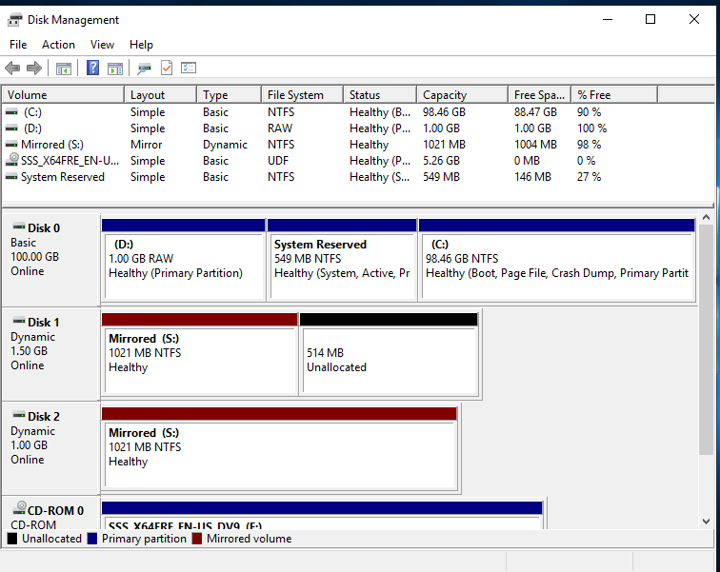   
     
   **Question 4 – What has happened to Drive S: and your text file?**  
   After removing “Disk-4-your-student-id,” Drive S: remains accessible because the mirrored volume uses the remaining disk to maintain data integrity. The text file remains intact and accessible on Drive S:.
2. Navigate to Disk Management, and capture your screenshot of it and paste it below:  
     
   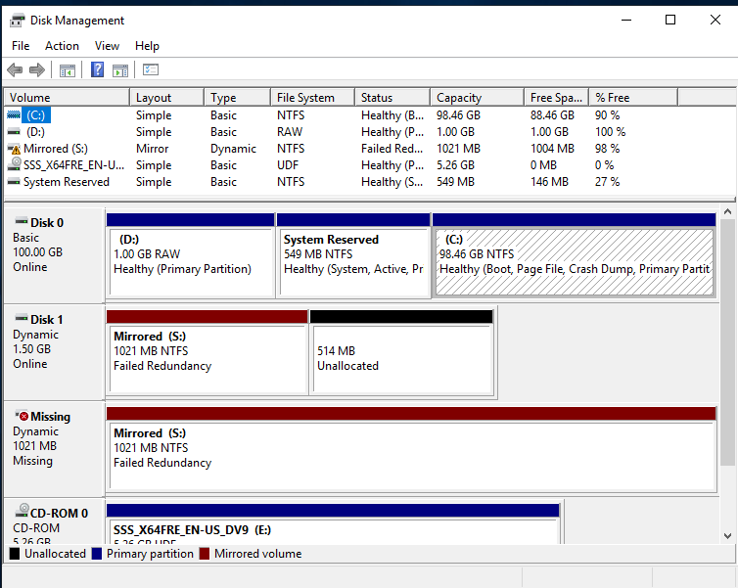  
     
   **Question 5 – Does a Mirrored Drive have any protection against disk failures?**  
   Yes, a Mirrored Drive provides protection against disk failures. If one disk fails, the data remains available on the other disk, ensuring no data loss occurs.

## Task 4 - Recovering from a failed Mirrored Disk

1. Capture your screenshot confirming this and paste it below:  
   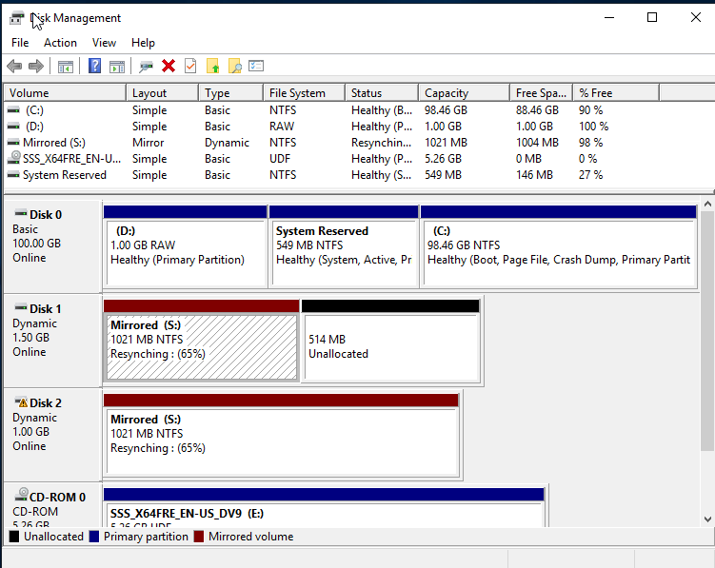

**Question 6 – What has happened to your text file?**  
After repairing the mirror, your text file remains intact and accessible. The mirroring process ensures data is duplicated across both disks, protecting against data loss during a disk failure.

## Task 5 - Creating a RAID 5 Disk

1. Paste your screenshot of the Disk Management screen here, similar to:

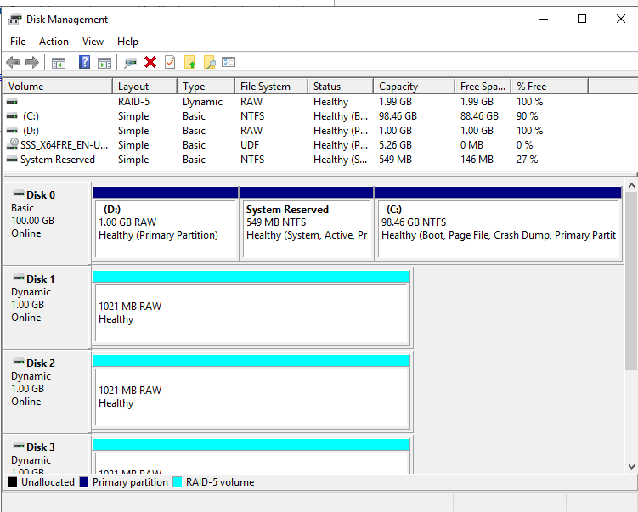

**Question 7 - What size is the resulting RAID-5 Disk?**

The resulting RAID-5 Disk size is 2GB. RAID-5 uses the equivalent of one disk's capacity for parity, so in this case, 3 x 1GB disks result in 2GB usable space.

**Question 8 – Does a RAID-5 Drive have any protection against disk failures?**   
Yes, a RAID-5 Drive provides protection against a single disk failure by using parity information distributed across the disks. If one disk fails, the data can be reconstructed from the remaining disks.

## Task 5

**Most organisations and data centres rely on some kind of networked storage. Research and explain the differences between DAS, NAS and SAN. How is RAID technology used in networked storage?**

Networked storage solutions are crucial for organizations and data centers to efficiently manage and protect their data. The primary types of networked storage are Direct-Attached Storage (DAS), Network-Attached Storage (NAS), and Storage Area Network (SAN). Each serves distinct purposes and offers unique benefits and drawbacks.

**Direct-Attached Storage (DAS)**

DAS refers to storage devices directly connected to a server or workstation, without a network in between. Common examples include external hard drives and internal storage drives connected via SATA or SCSI interfaces. DAS is simple, cost-effective, and offers high performance due to direct connectivity, making it suitable for single-server environments or small businesses with limited storage needs. However, it lacks scalability and centralized management, which can lead to challenges in data sharing and management in larger, more complex environments.

**Network-Attached Storage (NAS)**

NAS is a dedicated file storage system connected to a network, allowing multiple users and client devices to access data from a central location. NAS devices often use standard network protocols like NFS, SMB/CIFS, and HTTP. They are essentially specialized file servers, providing a convenient way to share files across a network. NAS is easy to set up and manage, and it supports data redundancy and protection features such as RAID. It is ideal for small to medium-sized businesses and home users who need a simple, reliable way to share files and back up data. However, NAS performance can be limited by network speed and congestion, making it less suitable for high-performance applications.

**Storage Area Network (SAN)**

SAN is a high-speed, specialized network that connects servers to a pool of storage devices. It uses protocols like Fibre Channel, iSCSI, and FCoE to provide block-level storage access, similar to a local disk. SANs offer high performance, scalability, and reliability, making them suitable for large enterprises and data centers with demanding applications such as databases, virtualization, and large-scale transaction processing. SANs are more complex and expensive to implement and manage compared to DAS and NAS, but they provide advanced features like storage virtualization, data replication, and disaster recovery.

**RAID Technology in Networked Storage**

RAID (Redundant Array of Independent Disks) technology is used in networked storage solutions to improve performance and provide data redundancy and protection against disk failures. There are several RAID levels, each offering different benefits:

* **RAID 0:** Stripes data across multiple disks, improving performance but offering no redundancy.
* **RAID 1:** Mirrors data across two disks, providing redundancy but with no performance gain.
* **RAID 5:** Stripes data and parity across three or more disks, offering a balance of improved performance, redundancy, and storage efficiency.
* **RAID 6:** Similar to RAID 5 but with an additional parity block, allowing for the failure of two disks without data loss.
* **RAID 10:** Combines RAID 1 and RAID 0, providing both redundancy and improved performance by mirroring and striping data.

In NAS and SAN environments, RAID is commonly used to ensure data availability and integrity. In NAS, RAID can be implemented within the device to protect against disk failures. In SAN, RAID configurations are often part of the storage arrays, ensuring that the large volumes of data stored are both secure and quickly accessible.

**Conclusion**

DAS, NAS, and SAN each serve different storage needs within organizations and data centers, from simple, direct-attached solutions to complex, high-performance networked storage systems. RAID technology plays a critical role in enhancing the performance, reliability, and data protection capabilities of these storage solutions, making it an essential component of modern networked storage architectures.